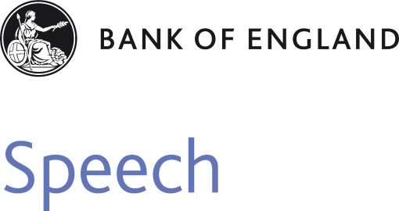

**In giving, how much do we receive? The social value of volunteering**

Speech given by

Andrew G Haldane, Chief Economist, Bank of England

A Pro Bono Economics lecture to the Society of Business Economists, London 9 September 2014

The views are not necessarily those of the Bank of England or the Monetary Policy Committee. I would like to thank Lynne Berry, Martin Brookes, Karen Hancock, Sue Holloway, Jane Walsh (Pro Bono Economics), Stephen Burgess, Jeremy Franklin, Charlotte Hogg, Joanna Konings, Lee Robinson (Bank of England), Daniel Fujiwara (SImetrica and London School of Economics), Matt Hill (Institute for Volunteering Research) and Valerie Fender (ONS).

I am delighted to be giving this joint Society of Business Economists (SBE) and Pro Bono Economics (PBE) lecture. The issue I want to discuss is volunteering and its contribution to the economy and wider society. This issue provides a natural link between the work of SBE with its interest in promoting the economy, and PBE with its interest in promoting volunteering by economists. And, indeed, the work of both in improving societal welfare.

Let me start with a word on PBE, for those unfamiliar with our work. PBE is a charity, which I co-founded around five years ago with Martin Brookes. Its aim, then and now, is to match economist volunteers into projects in the charitable sector, often to work on measuring the social impact of charities’ activities. In effect, PBE is a match-maker between economists and charities.

Why might we match-make between the uplifting art of charities and the dismal science of economics? Well, our hope was that there were significant gains from trade: on the charitable side, because of the rising pressures many charities have felt to demonstrate the impact of their interventions; and on the economist side, because of the usefulness of their applied skillset for tackling measurement issues of just this type.

Five years on, the heartening news for both sides is that these theoretical gains from trade appear to have been realised in practice. PBE has worked with over 170 charities, spanning such diverse issues as homelessness, eating disorders, child exploitation and prison rehabilitation. And we have matched over 170 economist volunteers into around 85 projects, with a large lump of unused economist labour waiting in the wings.

PBE’s experience illustrates nicely some of the broader points I wish to discuss about the value of volunteering – value not just to the *recipient* but also to the *provider* and to *wider society*. In other words, in giving our time through volunteering, we – individually and societally - stand to receive.

One of the aims of this lecture is to demonstrate that the societal gains from volunteering are potentially large

– and also largely under-appreciated. Certainly, they are not well measured. At least in official GDP statistics, they are not captured at all. This failure to recognise fully the value it creates means that volunteering suffers from a market failure problem. At the end, I will suggest a few avenues for correcting that failure.

# The Economics of Well-Being

Volunteering, and the work of PBE, fits under the broader umbrella of the economics of well-being. This has become a growth area of late. And, some might say, not before time. In his excellent recent report on

well-being, former Cabinet Secretary and PBE patron Gus O’Donnell quotes Robert F. Kennedy in 1968:1

1 Deaton *et al* (2014).

*“[GDP] measures neither our wit nor our courage, neither our wisdom nor our learning, neither our compassion nor our devotion to our country, it measures everything in short, except that which makes life worthwhile.”*

Economists, from Simon Kuznets in the 1930s onwards, have long been aware that GDP does not measure social welfare (Coyle (2014)). But, then and now, it remains the best available proxy of the volume of the goods and services an economy produces.2 For this reason, it remains an essential ingredient when assessing and managing the economy – for example, when doing my day job of setting monetary policy.

But there are indisputably a much broader range of indicators that are relevant when assessing the welfare of society more generally. For that reason, in their report for the *Commission on the Measurement of Economic Performance and Social Progress* (CMEPSP), Stiglitz, Sen and Fitoussi recommended a shift away from measures of economic production towards measures of economic *well-being*.3

This is easier said than done technically. One approach is to take a set of metrics that are likely to shape an individual’s well-being and combine them – for example, income and wealth, health and education, leisure and work activities, political voice and governance, social connections and relationships, the environment and insecurity.

Another is to ask people about the level of their well-being directly, so-called measures of

Subjective Well-Being (SWB). Although that approach may sound simpler, it is not without measurement problems. Survey responses are influenced importantly by factors such as context and framing, which hinders comparability across time and countries.

Despite being a fledgling science, several organisations and statistical agencies have started to construct indices of societal well-being. Here in the UK, the Office for National Statistics (ONS) now publishes measures of National Well-being in their annual ‘Life in the UK’ report.

According to the latest data, more than three-quarters of the UK population are satisfied with their lot. I confess to being a touch surprised by this statistic. It is certainly considerably higher than my own informal sample of rail commuters’ faces each day into and out of London.

Internationally, the UN has recently published its second *World Happiness Report* (United Nations (2014)). The UK ranks a respectable 22nd out of 156 countries. The OECD publishes a range of well-being indicators as part of its *Better Life Index*. An un-weighted average of its indicators ranks the UK 12th out of the

36 countries (Figure **1**). The UK does well on measures of income, wealth, security and environment, less well on work-life balance, education, skills, and housing (Figure **2**).

2 Coyle (2014).

3 Fitoussi *et al* (2009).

I set out all of this because it has a direct read-across to measuring the societal value of volunteering, to which I now turn.

# The Scale of Volunteering

You can only measure what you can first define. The International Labour Organisation (ILO) defines volunteering as:

*“Unpaid, non-compulsory work; that is, time individuals give without pay to activities performed either through an organisation or directly for others outside their own household”.*

Within this, there is *formal* and *informal* volunteering. The former is done through groups, clubs or organisations and is typically easier to measure; the latter can be through any arrangement and so is often much harder to capture.

Clearly, volunteering is work. It also involves producing goods or services outside of your own household. So playing a musical instrument for your own pleasure does not count as volunteering, but playing in an old people’s home does. Driving your children to hospital is not volunteering, but driving your neighbours to hospital is. And so on. Figure **3** gives some more examples taken from the ILO manual.

Given this definition, measuring volunteering activity is likely to be a tricky business. Would you know how many hours you had spent over the past year helping your neighbours? Those London commuters might know – a roundish number? - but the rest of the UK population is unlikely to keep score.

Household surveys can help. In the UK, the Community Life Survey and the British Household Panel Survey (BHPS) ask respondents about the nature and scale of their volunteering activities. Although far from perfect, they enable us to build up a good overall picture of the volunteering sector. And what a picture they paint.

First, the *volunteer army in the UK is huge*. Figure **4** illustrates the extent of participation in voluntary activities in 2012, based on the Community Life Survey. Around 44% of respondents had done some form of formal voluntary work over the previous 12 months and 29% volunteer formally at least once a month. This means around 15 million people in the UK volunteer ‘frequently’.

Looking at hours worked, this equates to just over 2 billion hours per year spent formally volunteering. To give you some context, that is just under one hour per week for every person over 16 in the UK. It is 5% of

the total hours worked in the UK by paid employees. It is equivalent to 1.25 million full-time equivalents (FTEs), or double the number of paid FTEs in the voluntary sector. 4

Put differently, there are around the same number of FTE volunteers in the UK as there are paid employees in the Construction, IT or Financial Services sectors. Indeed, there are more FTE volunteers than paid employees in nearly half of the industrial sectors in the UK.

And it does not end there. It is estimated that another 170 million hours a year are volunteered by people less than once a month.5 And to this estimate of formal volunteering should be added measures of informal volunteering. According to calculations recently released by the ONS, informal volunteers provide anywhere between 1.7 and 2.1 billion hours of extra help each year.6

So, all in, volunteering in the UK might amount to as much as 4.4 billion hours per year. That is 1.7 hours per week for every UK adult aged over 16. It is not far off 10% of the total hours worked by all UK paid employees. That is quite an army.

Second, *volunteering also appears to be big internationally*. A group of academics at John Hopkins University have been pioneers in this field and have published cross-country comparisons.7 They calculated that, in 2005, around 970m people in the world were engaged in voluntary activity. Given the growth in world population over the period since, the number of global volunteers may well now top the one billion mark.

To put that in context, imagine if these volunteers comprised a single country - ‘Volunteerland’. It would have the second largest working age population of any country in the world, behind only China (Figure **5**).

The Charities Aid Foundation calculates a *World Giving Index* each year which ranks the generosity of people in different countries with their money and time. For volunteering, top of the league are the unlikely trio of Turkmenistan, Sri Lanka and the United States; bottom of the pack are Yemen, China and Greece. The UK ranks 26th out of 131 countries. This is respectable, if outside an automatic Champions League place (Figure **6**)

Of course, cross-country comparisons can be quite difficult. For example, the high rates of volunteering in ex-Soviet states, like Turkmenistan and Uzbekistan, are in part down to the authorities having national days of volunteering – “subbotniks”. As these are more or less compulsory, they stretch to breaking point the definition of volunteering.8

4 Bank and Pro Bono Economics calculations using ONS Household Satellite Account hours.

5 Bank and Pro Bono Economics calculations using ONS Household Satellite Account hours.

6 See [http://www.ons.gov.uk/ons/about-ons/business-transparency/freedom-of-information/what-can-i-request/published-ad-hoc-](http://www.ons.gov.uk/ons/about-ons/business-transparency/freedom-of-information/what-can-i-request/published-ad-hoc-data/econ/august-2014/hhsa-consistent-estimates-of-the-value-of-informal-voluntary-activity-in-2012-13.xls) [data/econ/august-2014/hhsa-consistent-estimates-of-the-value-of-informal-voluntary-activity-in-2012-13.xls](http://www.ons.gov.uk/ons/about-ons/business-transparency/freedom-of-information/what-can-i-request/published-ad-hoc-data/econ/august-2014/hhsa-consistent-estimates-of-the-value-of-informal-voluntary-activity-in-2012-13.xls) for further details.

7 Salamon *et al* (2011).

8 See for example [http://enews.fergananews.com/news.php?id=2697,](http://enews.fergananews.com/news.php?id=2697) describing a recent subbotnik in Uzbekistan in August 2013.

Third, the *volunteer army is a diverse one*. Volunteering is slightly more prevalent among older people and slightly less prevalent among people of child-rearing age (Figure **7**). But all age groups make a significant contribution. Women and men are broadly equally likely to volunteer. And there do not appear to be major differences in volunteering across ethnic minority or socio-economic groups. 9

Fourth, *numbers of volunteers appear to be stable* (Figure **8**). There is some evidence of cyclicality in volunteering, with it falling at the start of the recession and rising during the recovery. A recent report suggested that volunteering numbers had reached a ten-year high.10 It is possible this upward trend will continue. An ageing population will boost older cohorts where volunteer participation rates are high. And among younger cohorts there is evidence of a behaviour shift, with participation rates having doubled in the past decade.

Taken together, these patterns suggest that volunteering is tightly-woven into the UK’s social fabric – a fabric which is large, diverse, international and potentially growing.

# Measuring the Value of Volunteering

So far we have established that labour inputs into volunteering are considerable. But this does not tell us what *value* these volunteers create for the economy, much less for society. This is important when gauging the contribution volunteering makes to societal welfare.

It is possible to build up an incremental, if somewhat piecemeal, picture of this contribution from its various sources. These are shown schematically in Figure **9** as layers of a “volunteering onion”. At the centre of the onion are the volunteer army, all 15 million of them. The outer three layers then measure respectively:

* The *economic value* of goods and services created by volunteers – if you like, the GDP-equivalent value of volunteering services;
* The *private value* of volunteering activities, in particular the benefits felt by volunteers themselves; and
* The *social value* of volunteering activities, as societal gains may be a multiple of economic and private benefits.

I want to build up a quantitative picture of these various layers. They take us from a conventional,

GDP-centric measure of economic value through to a more fashionable, wellbeing-centric measure of social

9 Volunteering England (2009).

10 Guild *et al* (2014).

welfare. In other words, this approach combines elements of both the old and the new when determining the value of volunteering.

Before diving into methodology, let me just highlight a few general caveats:

* First, these value layers – economic, private and social - may not be entirely distinct. For example, the private benefits from volunteering may be the very reason people volunteer in the first place and create economic value. So we should hesitate before simply adding these benefits together. I will try to resist doing so, but will probably fail.
* Second, value measurement becomes harder the further out you go from the centre of the onion. We can make reasonably informed guesses about the economic value of volunteering, by adapting national income accounting techniques. And we can construct some reasonable proxies for private benefits from various surveys. But we have only piecemeal evidence on measuring the social value of volunteering. This, in short, is a fledgling science.
* Third, it is striking that virtually none of these onion layers is captured by official statistical measures of activity, such as GDP. And, indeed, only some are captured by broader measures of subjective well-being. Measuring the value of volunteering typically relies on secondary, often non-official, statistical sources.

In combination, this means that very little of the value created by the volunteer sector is easily visible to statisticians, to policymakers, to politicians, to companies, indeed to the volunteers themselves. This is a vast, but often invisible, army. So let me try to improve that visibility somewhat by piecing together some evidence.

# The Economic Value of Volunteering

Let’s start with the easiest bit – the economic value of volunteering. In other words, when volunteers give up their time to paint a building, take an elderly neighbour to hospital or feed the homeless, what is the value of the output they are producing?

GDP measures the monetary value of goods and services produced in an economy. Because it is not normally associated with a monetary transaction, volunteering activity is not captured by existing GDP statistics. This point is well-recognised by statisticians, which is why the ONS publishes a series of Satellite Accounts to pick up important sources of activity which lie outside GDP.

The Household Satellite Accounts are one example. They measure activities like childcare, adult care, meal production, laundry services and also the work of volunteers which do not involve a monetary transaction. In aggregate, these activities are huge. According to the Satellite Accounts, were they included they would increase GDP by around 80%.

In an ideal world, we would observe the output of volunteers – the goods and services they produce – and work out what they could fetch in the market, just as with GDP. But there is no market for services in which no monetary transaction is involved.

What the ILO recommends instead – and what the ONS does in practice – is to capture the value of the labour *input* used in producing these services, as a proxy for their market value. Specifically, the ONS identifies particular voluntary activities from household surveys and then maps those to paid occupations. Taking the median hourly wage for those occupations, and multiplying by the number of hours volunteers provide, gives an estimate of the volunteering sector’s output on a replacement cost basis.

Using this method, the ONS calculates that frequent, formal volunteering produced just short of £24 billion of economic output in 2012. This would be equivalent to 1.5% of GDP. That is sizable. It would make volunteering one of the most important industrial sectors in the UK, producing twice as much value as the agriculture sector and about the same amount as the telecoms or the insurance and pension fund sectors.

Of course, any estimate relies on certain assumptions. Let me highlight three important ones. First, these estimates consider only formal and frequent volunteering. Second, they assume that the productivity and the quality of volunteer’s work is the same as comparable paid workers. And third, they assume that wages are a reasonable guide to output.

Taken together, these assumptions may if anything bias *downwards* estimates of the value of volunteering. So it is instructive to tweak them to gauge possible biases (Figure **10)**.

* The first rows in the table show what might happen if you included all forms of volunteering. *Infrequent* volunteering does not add that much – the Household Satellite Account suggests around a further £1.7bn each year. But *informal* volunteering is much more substantial. The ONS recently released an estimate of informal volunteering in 2012 which puts the figure at almost £19 billion – not far off the contribution from formal volunteering.11 This should reasonably be added to overall estimates of the economic value of volunteering.
* For most private sector firms actual output is a mark-up over labour costs, reflecting productivity gains and returns to capital. It is hard to know for sure whether the volunteering sector follows the

11 These new estimates can be found at [http://www.ons.gov.uk/ons/about-ons/business-transparency/freedom-of-information/what-can-i-](http://www.ons.gov.uk/ons/about-ons/business-transparency/freedom-of-information/what-can-i-request/published-ad-hoc-data/econ/august-2014/hhsa-consistent-estimates-of-the-value-of-informal-voluntary-activity-in-2012-13.xls) [request/published-ad-hoc-data/econ/august-2014/hhsa-consistent-estimates-of-the-value-of-informal-voluntary-activity-in-2012-13.xls.](http://www.ons.gov.uk/ons/about-ons/business-transparency/freedom-of-information/what-can-i-request/published-ad-hoc-data/econ/august-2014/hhsa-consistent-estimates-of-the-value-of-informal-voluntary-activity-in-2012-13.xls)

same pattern. But in those industries involving ‘labour-intensive services’, like volunteering, the labour share of output is about 80%.12 In other words, the economic output of those services is about a quarter more than the labour costs. As the third row in Figure **10** suggests, if volunteering activities are similar in nature, there is a case for scaling-up our estimates of output by a similar amount.

* The final issue, outlined on the fourth row of Figure **10**, is about comparing volunteers with paid workers. In carrying out the same activity as a paid employee, volunteers may be more enthusiastic, but also less capable. I am more enthusiastic about painting a shed than my local decorator, but also less competent. So it is not altogether clear whether the wages of paid workers are good proxies for volunteering value or not, with uncertainties on both sides.

The final row in Figure **10** offers estimates of the overall contribution of volunteering to the UK economy. It suggests this *could* exceed £50 billion per year, or around 3.5% of annual UK GDP. This would place the volunteering sector on a level pegging with the UK energy sector (both extraction and utilities). Very few sectors add more value. Clearly, the inner layer of the volunteering onion – economic value - is a very significant one.

# Private Value of Volunteering

The second layer of the onion is the private benefit from volunteering. This might sound fluffier than a GDP-equivalent measure. Yet even the hardest-nosed economist would recognise the existence of those private benefits. Why else would anyone volunteer in the first place! Volunteering is a prime example of revealed preference theory in practice.

Surveys of individuals overwhelmingly support this conjecture. The 2006/07 *Helping Out* survey of volunteers found a range of benefits including enjoyment, satisfaction and achievement, meeting people and making friends, broadening life experience, boosting confidence, reducing stress, improving physical health and learning new skills (Figure **11**).

The balance of benefits differs across individuals. For example, younger people are most likely to highlight the importance of acquiring new skills and enhancing employment prospects, while older volunteers see the benefits from increased social interaction and improved health. But enjoyment and satisfaction rank high across all volunteer types.

12 This calculation uses the following industries: professional and support services; distribution, transport, hotels and restaurants; government, health and education; and other services. The calculation also includes an adjustment for “mixed income” – that is, the income of the self-employed that is classified separately in the national accounts but which arguably reflects a return to labour rather than capital.

This survey evidence is consistent with PBE’s experience. Our economist volunteers are often young. PBE offers the chance to apply existing skills to different sets of problem in very different environments. I think without exception, PBE volunteers have found projects enjoyable and satisfying – and, especially among government economists, liberating too.

Digging a little deeper, these self-reported benefits appear to fall roughly into three categories: *enhanced well-being*, *health benefits* and increased *skills and employability*. It is worth considering the evidence on each in turn.

1. *Enhanced well-being*

There are various ways of assessing the impact of volunteering on individual well-being. These include ‘stated preference’ surveys, where people are asked directly about how factors affect their well-being. But what people say and do are not always the same – and several studies have shown that this approach may lead to systematic upward biases.13

Perhaps the most authoritative method is to use national surveys of well-being and life satisfaction alongside data on the characteristics of the survey participants. This approach lies behind the recent report by Fujiwara *et al* (2014). This report estimates the impact of various factors, including formal volunteering, on an individual’s life satisfaction.

Their results provide a relatively clear ranking of what factors really matter for well-being. Health (physical and especially mental) comes at the top of this well-being league table, followed by employment prospects. On the next rung down, however, sits volunteering. In terms of personal well-being, this puts volunteering on a similar footing to playing sport.

If you were wondering where watching TV would come in the well-being list I can tell you – close to the bottom. Indeed, watching TV is found to *detract* from well-being.14 This I think confirms what we all knew deep down: *X-Factor* is bad for you.

It is possible to translate these into monetary-equivalent values – the money an individual would need to be given to increase their well-being by the same amount. On this evidence, you would need to be compensated around £2,400 on average per person per year for forgoing the opportunity to volunteer.15 That is a very significant sum for the average person, whose median annual salary was only £22,000 in 2013.16

13 Campbell *et al* (2011).

14 This was not estimated in Fujiwara *et al* (2014), but estimates of the impact of TV on well-being are available in Frey *et al* (2007).

15 The exact figure is £2,357 from Fujiwara *et al* (2014).

16 This is for all employee jobs from the ONS Annual Survey of Hours and Earnings.

If you multiply that per-person benefit by the 15 million or so regular volunteers, you get a private benefit of volunteering close to £40 billion per year.17 If you added in non-regular volunteers, you would get a larger number still. In other words, adding together private and economic benefits roughly doubles estimates of the value of volunteering, to something perhaps closer to £100 billion per year.

1. *Health benefits*

The Centre for Mental Health estimates that the economic and social costs of mental health problems are huge. The health and social care costs alone are worth over £20bn, the associated output losses £30bn and the human costs over £50bn. So anything that improves mental health, even in a small way, can make a big difference to social welfare.

Volunteering is typically found to have a positive impact on mental health – for example, by enhancing social integration and engagement.18 Certainly, that is what volunteers themselves say. Remaining active and socially engaged can be particularly important for older age groups, post-child raising and post-retirement.

A systematic review of the international literature by Casiday *et al* (2008) assessed 43 longitudinal, cross-sectional and qualitative studies of the impact of volunteering on mental health. It found that

volunteering reduced the incidence of depression, stress, hospitalization, pain and psychological distress.

It is difficult to put precise numbers on those benefits. But Fujiwara *et al* (2014) find that, on average, the well-being benefit from relief from depression or anxiety is worth around £37,000 per year. And

New Economy Manchester (2014) estimate that the average cost of treating those suffering from depression or anxiety is around £956 per year.19 Even a small effect from volunteering on mental health could deliver large benefits.

1. *Increased skills and employability*

The evidence on the impact of volunteering on employability is more mixed. Ellis Paine et al (2013) find a significant, but weak, effect of volunteering on the probability of finding a job. Not all types of volunteering will lead necessarily to better employment outcomes. And it is important not to overlook the potential benefits from volunteering felt by *employers*, as well as their employees.

A recent poll by YouGov found that nearly all managers believe that workplace skills can be gained from volunteering.20 And recent research suggests a link between the emotions induced by volunteering (like

17 This figure is calculated as the estimated impact on well-being from volunteering (£2,400) x the number of volunteers in the UK (15m)

= £36bn.

18 Casiday *et al* (2008).

19 For further details see <http://neweconomymanchester.com/stories/832-unit_cost_database>

20 For further details see Volunteering England: <http://www.volunteering.org.uk/who-we-can-help/employers/the-business-case-for-esv>

confidence and self-esteem) and factors important in the workplace (like performance ratings and efficient problem solving).21

Oswald et al (2014) provide evidence that happiness makes people more productive. If randomly selected individuals are made happier – for example, by having their TVs removed on a Saturday evening - they are approximately 12% more productive. Since we know volunteering has a significant impact on an individual’s well-being, it is a short step to think it is also productivity-enhancing.

That, too, is consistent with PBE’s experience. Employers of the economists used by PBE as volunteers have often given fed back that this has enhanced their motivation and skills. And it is worth just putting in context how big a potential benefit that could be. If the UK’s 15 million volunteers were each 5% more productive, that would deliver a boost to national income of £23 billion each year.22

Once you tot up the private benefits of volunteering – well-being, health, skills – something quite striking becomes apparent. The benefits to volunteering might be as large, if not larger, for volunteers *themselves* as for recipients. In other words, in giving we really do receive – possibly as much as we give!

That hard-headed economist I mentioned earlier would at this stage spring to their feet. Brandishing revealed preference theory, they would say this is obvious - that it is these very benefits that explain why the volunteer army exists in the first place.

And, once again, they would largely be wrong. For research has shown that people tend systematically to under-estimate the positive effect for *them* of giving to others. In a nice experiment, people were randomly assigned $20 to spend, either on themselves or others. Those who were told to spend it on others subsequently reported significantly higher subjective well-being ex-post, contrary to their expectations

ex-ante.23

This means that volunteer army would possibly be *larger still* if individuals had greater *self*-awareness of the private benefits of volunteering. When it comes to volunteering, preferences may be as much concealed as revealed.24

# Social Value of Volunteering

Finally, let’s consider the social welfare benefits of volunteering. Why might these differ from the economic and private benefits? And by how much?

21 Estrada *et al* (1997), Wright and Staw (1999), Diener *et al* (2005).

22 This estimate assumes just under 60% of these volunteers are in employment, in line with the UK employment rate.

23 Dunn *et al* (2014).

24 Dunn *et al* (2014).

Let’s take a simple example. Consider a volunteer who helps out a charity providing support services for the homeless. Is the value of this activity captured by the hours spent volunteering? By the amount it would have cost to hire that person to provide that help? By the amount that person themselves benefit from volunteering?

Well, all of the above are important and large, as I have shown. But they would still potentially significantly under-estimate the value *society* should place on this activity. That is because homelessness comes with wider collateral costs, for the individual most obviously, but also for society generally: the reduction in employment and income prospects; the accompanying increased risk of criminal activity and addiction to drugs or alcohol; and the increased risk of physical and mental health problems.

All of these take a very significant toll on the homeless individual. But they also tax the public purse, through increased social security, criminal justice and health spending. And that is before you even get to the wider social costs of, for example, criminality and addiction on families and societies. These costs are a form of societal externality.

The social value created by reduced homelessness is, then, a potential multiple of the cost of the labour input to volunteering. But how large a multiple? Well, I can tell you. And the reason I can tell you is that my thought experiment is not a hypothetical one.

Last year, PBE brought together a team of volunteer economists from Oxera Consulting with a charity called Centrepoint which does wonderful work with homeless young people in London.25 Centrepoint were keen to evaluate quantitatively the social benefits of their work. So the Oxera team sought to capture the benefits of reducing homelessness in getting young people into employment or training, preventing them from

re-offending, treating their mental health issues and reducing their substance misuse. These are a subset, albeit an important subset, of the social costs of homelessness.

The results of this study, which was published by PBE last year, are outlined in Figure **12**. To cut a long story short, the study suggested that, for every £1 spent by Centrepoint, there was a societal benefit of at least £2.40. Or, put differently, Centrepoint delivered a social return on investment of 140% over a five year period. This was very much a lower bound estimate.

Let me give you a second example of a PBE social impact study, this time on an even grittier issue – child sexual exploitation. In 2012, a PBE team from the Bank of England did a piece of work for Barnardo’s to judge the impact of their interventions to help exploited children.26 They looked at the reduced incidence of missing person calls to the police, the reduced probability of becoming classified as Not in Employment, Education or Training (NEET), reductions in substance misuse and the benefits from secure accommodation.

25 PBE (2013).

26 PBE (2011)

These benefits are outlined in Figure **13**. They suggest a higher social welfare multiplier, perhaps as large as six to twelve.

This is not miles away from estimates from a recent City of London study. This found that, when a business invests £1 in employability-related employee volunteering, the social return is over £11 for society.27

Of course, the precise social multipliers are likely to vary, charity by charity. To give you some idea of scale, the lowest multiplier we have found from one of PBE’s studies to date is around 2.5, while the highest runs into double-figures. And while the number of studies conducted by PBE is too small to constitute a representative sample – there are around 161,000 UK charities28 – these studies demonstrate clearly two things.

First, that evaluating these social benefits is usually possible, if sometimes with difficultly and imperfectly. And second, at least in the cases we have considered so far, the social returns from the voluntary sector, and hence from volunteering, can be significant multiples of the labour input cost. Social multipliers are typically well in excess of one.

Despite this, the number of charities who have actually undertaken social cost-benefit analyses is depressingly small. Research by New Philanthropy Capital in 2012 found that 25% of charities surveyed, and nearly half of those with income below £100,000, do not measure their impact at all. Given that charities with income below £100,000 make up roughly 80% of all general charities, this means there is a huge number whose activities are not evaluated.29

This has all the classic symptoms of a market failure: social welfare externalities which are not being understood, much less tackled. The reason is not difficult to fathom. Social cost-benefit analysis requires skills which charities themselves can rarely afford to hire. Or, put differently, as a charity why would you spend money on an analyst if it came at the expense of helping a homeless person or a sexually-exploited child? You wouldn’t – and, in the main, they don’t.

It is precisely this market failure that PBE was created to help correct. Economists have precisely the analytical skills that charities themselves can ill-afford. If these skills are volunteered, then they can be matched into charities to help plug that societal externality. That is why studies evaluating the social benefits of charitable interventions have been a key element of PBE’s work since its inception.

27 See [http://www.volunteering.org.uk/resources/esv-resource-hub/case-studies.](http://www.volunteering.org.uk/resources/esv-resource-hub/case-studies)

28 UK Civil Society Almanac 2014, National Council for Voluntary Organisations (NCVO).

29 Ní Ógáin *et al* (2012).

# Volunteering and Public Policy

So where does this leave us? Let me now do what I told you at the beginning I would try to resist, by adding-up the layers of the volunteering onion:

* + We have a volunteer army, the full-time equivalent of 1.25 million people, diverse in age, gender, background and ethnicity and potentially growing in number.
  + They create each year economic value of at least £50 billion and potentially higher.
  + They create private value for individual volunteers of maybe as much again.
  + And although the confidence intervals are large, it would not be unreasonable to apply a social multiplier of upwards of two to these estimates.

However you cut this onion, it is clear that the value it creates is eye-watering. And this is value, let’s remember, much of which is not captured or visible from official statistics. This is a largely invisible onion.

Now, it is fair to say that I have not much discussed any *costs* of volunteering. Plainly, no activity is costless, both in a direct and opportunity cost sense. But the evidence here, however imperfect, suggests some significant benefit multipliers from volunteering, economically, privately and socially.

Given that, could this value be leveraged by changes, large or small, public or private? There are already a number of organisations who support volunteering. For example, Volunteering England is a UK-based independent charity providing a range of services to assist employers and potential volunteers take part in volunteering activities.

The National Council for Voluntary Organisations (NCVO), which recently merged with Volunteering England, champions volunteering activity, from practical how-to guides to video training courses to bespoke advice.30 One of their members, the Institute for Volunteering Research (IVR), provides a range of tools to help employers understand the costs associated with setting up volunteering schemes.

Let me offer just a few reflections of my own on other possible avenues. The fact that a sector is creating societal value does not, by itself, imply the need for public policy intervention. Nonetheless, there may be policy “nudges” which might lower frictions, or sharpen incentives, in ways which could enhance the value already being created.

30 For further details see [http://www.ncvo.org.uk/practical-support.](http://www.ncvo.org.uk/practical-support)

## *Increasing Visibility*

The key theme of this lecture is that the value created by volunteering is rarely well-measured or

well-understood, especially when it comes to the wider social benefits. There is an information gap. This gap puts grit in all components of the volunteering machine, in ways which potentially inhibit its scale and effectiveness.

Take volunteers themselves. Individuals’ behavioural biases lead them systematically to under-estimate the private benefits from philanthropy and volunteering. And state-of-the-art econometrics suggests these benefits may be substantial, the monetary equivalent of more than a month’s work for the average person.

One implication is that volunteering may be being systemically under-supplied relative to what even private individuals would desire. Or, put more positively, both individuals and society stand to gain from a better appreciation of these private benefits. This could be achieved through more research. But, perhaps more importantly, there may be a case for considering a public education programme which helped explain and popularise these benefits more widely.

What is true of private benefits is true, perhaps to even greater extent, of societal gains. A greater understanding of these stands to benefit funders of charities in deciding where best to allocate funds; charities themselves when deciding where best to allocate their energies; and policymakers to the extent they wish to encourage the creation of these quasi-public goods.

To give one example from the funding side, through joint research with Oxford Economics the homelessness charity CRISIS found that for every £1 invested there was a saving to society of £4.37.31 On the back of this, CRISIS began offering “investment units” as a way of emphasizing the social return on a donation.

A more formal way of linking funding to social returns is through Social Impact Bonds (SIBs). These allow socially-minded investors to fund the provision of a service delivered by a social enterprise or charity, with a return on their investment from government if the service delivers the results specified. In fact, last year’s Rybczynski prize, awarded by SBE, was on work looking at the use of payment by results in the criminal justice system. So far, 14 SIBs have been issued.

But social impact measurement remains the exception, not the rule. And SIBs remain a fledgling asset class. Underlying this is not so much an information gap as a chasm. It is puzzling that a sector whose core contribution is to societal well-being does not do a better job of measuring that contribution. Charities like PBE are seeking, on a small scale, to bridge that chasm through our measurement work. But we are under no illusion that, so far at least, we have only skimmed the surface.

31 For further details see: [http://investors.crisis.org.uk/.](http://investors.crisis.org.uk/)

## *Skills and Time Matching*

There are several obvious frictions in the matching process between volunteers and socially-worthwhile activities, which potentially reduce the effectiveness of volunteering or the likelihood of it happening in the first place. One is time. It is not surprising that time is the most cited barrier to volunteering (Figure **14**).32 But technology, as in every other aspect of life, can improve the efficiency of matching in ways which can stretch time.

We have recently seen the emergence of a number of charities with support what the NCVO have called “micro-volunteering”. For example, “Help from Home” is an initiative to encourage micro-volunteering by allowing people to donate as little as 5 minutes to a worthy cause. For example, you can spend a few minutes describing photos to improve a blind person’s experience of a museum, play an online game in aid of scientific research, or write an email to a sick child. Tasks are given a ‘pyjama-rating’ to drive home the message that it is easy to volunteer.

A second friction is appropriately matching the skills of volunteers to those activities where they would be best put to use. PhD economists are no less capable of painting sheds or cleaning riverbeds than the next person. But this is unlikely in general to be the best use of their skills and time, nor the charities. This was one of the key motivations behind PBE - to harness the skills of economists in ways which most benefitted charities.

And what is true of economists is no less true of other professions and occupations, whose skills might be better targeted and harnessed than at present. It is known that using their skills is more likely to persuade someone to volunteer in the first place.33 One example of that would be the charity “Datakind”, which harnesses the skills of budding data scientists to help solve social problems. More generally, the potential to improve further such skill-matching between volunteers and charitable activities is considerable.

## *Employer Incentives*

It is in employers’ power to make volunteering work in their firms - for example, by allowing flexible working hours or a certain amount of paid volunteer leave. It is also, as I have discussed, potentially in their own interest from a satisfaction and productivity perspective.

A number of employers appeared to have heeded that message. For example, in 2011 the Civil Service began formally encouraging civil servants to spend one day a year volunteering – “to turn the civil service into a civic service”.34 My home institution, the Bank of England, adopts a similar approach.

32 Citizenship Survey 2010/11.

33 Meier and Stuzer (2004).

34 See https://[www.gov.uk/government/news/next-steps-in-turning-the-civil-service-into-a-civic-service](http://www.gov.uk/government/news/next-steps-in-turning-the-civil-service-into-a-civic-service)

In support of this, volunteering England provide online guidance to help employers set up Employer Supported Volunteering (ESV) schemes. Their website lists a variety of organisations that have

well-established schemes ranging from the big supermarkets to local councils.35 Within the private sector, around 70% of FTSE 100 companies already have some kind of employer-sponsored volunteering programme.36 Perhaps unsurprisingly, that percentage is much lower for small and medium-sized businesses. This is a decent starting point.

Yet my suspicion is that many companies are still not close to recognising fully the benefits from volunteering. And let me illustrate that with one startling fact courtesy of Lynne Berry, a PBE trustee and expert on the sector. Among those FTSE 100 companies, how many Board members are drawn explicitly from the voluntary sector? Precisely one. That is not consistent with volunteering having entered the corporate bloodstream. Nor is the fact that 30% of the UK’s largest companies still do not have a volunteering programme.

My hunch is that, over time, more companies will need to recognise the benefits of volunteering, not just among Board members but among employees. Why? The two Rs - recruitment and retention. Generation Y, born from the 1980s onwards, place a much greater weight on a diverse career experience, with a strong social dimension, than their predecessors. And Generation Z, the Millennials, are unlikely to buck that trend. Where they lead, companies will surely need to follow.

## *Shifting social norms*

Given the quasi-public good nature of volunteering, it is possible to conceive of more ambitious proposals still through which the state could encourage volunteering.

A few countries have sought to do so by mandating it. But this “subbotnik” approach risks turning a social opportunity into a statutory obligation.

One way of shaping social behaviour is to catch volunteers when they are young. Once volunteering is a habit, it might last a lifetime.37 The US has experience of such programmes. Their Peace Corps have a larger, but less well-known, domestic counterpart – AmeriCorps. AmeriCorps provides members with full or part time positions in non-profit community organisations and public agencies. Not only do volunteers learn valuable life skills, such as teamwork and leadership, but the scheme also makes contributions to the costs of their education. Since its introduction in 1993, AmeriCorps has had 900,000 volunteers enter its programme, with over 75,000 participating in 2012 alone.

35 For further details see [http://www.volunteering.org.uk/who-we-can-help/employers.](http://www.volunteering.org.uk/who-we-can-help/employers)

36 CSV, ‘Employee Volunteering: Who is benefitting now?’ (2013). See [http://www.volunteering.org.uk/who-we-can-help/volunteer-](http://www.volunteering.org.uk/who-we-can-help/volunteer-involving-organisations/employer-supported-volunteering/the-business-case-for-esv) [involving-organisations/employer-supported-volunteering/the-business-case-for-esv](http://www.volunteering.org.uk/who-we-can-help/volunteer-involving-organisations/employer-supported-volunteering/the-business-case-for-esv)

37 Halpern (2004), Putnam (2000)

Here in the UK, the National Citizen Service (NCS) was introduced in 2011. It recently passed the milestone of 100,000 young people having taken part. This scheme runs outside term time for 15-17 year olds and combines opportunities to take part in adventure activities with social action projects. The evidence so far suggests this scheme, as well as being enjoyable, increases the chances of participants subsequently volunteering.38

It is possible to imagine ways of building on that success. For example, the NCS programme only covers holiday periods and participants pay a small fee to participate. By contrast, the AmeriCorps programme lasts for up to a year and participants are offered financial support towards educational costs. This has meant AmeriCorps has not only encouraged volunteering; it has also provided incentives for generations of Americans, especially from poorer backgrounds, to stay on in higher education. This small financial nudge has thus potentially delivered lifelong returns.

More generally, the UK already encourages giving *money* by allowing charities to reclaim tax on donations through ‘Gift Aid’. Is there a case for providing tax-based incentives for people who instead volunteer *time*? The idea is not without precedent. In 2008, the Canadian Parliament debated a bill that proposed taxpayers who volunteer at least 250 hours be issued a tax credit up to $1,000.39 It was rejected. But since 2011, Canadian firefighters, most of whom are volunteers, have received a tax credit of $3,000 if they complete over 200 hours of volunteering a year.

Such a policy may sound ambitious, certainly administratively, as it would require auditable records of volunteer hours worked. But it is not impossible to conceive of a system of Individual Volunteering Accounts (IVAs) for people engaged in formal volunteering. Relative to the value created, the administrative costs would probably be modest.

Once in place, those IVAs could serve a number of useful purposes. As an additional way of sharpening incentives, individuals could be recognised or rewarded, locally or nationally, for passing certain volunteering milestones – 5,000 hours, 10,000 hours etc. If we wanted a more systematic way of calibrating the UK honours system, what better metric than the credit balance in an individual’s IVA?

# Conclusion

So let me briefly sum up. Whether seen from an economic or social perspective, volunteering is big business, with annual turnover well into three-figure billions. But it is a well-hidden jewel, whose social worth is rarely the subject of a public valuation. One of the purposes of this lecture was to provide such a valuation, however imperfect.

38 Booth *et al* (2013).

39 Around £550.

If the value of volunteering remains largely out of sight, it is likely also to remain out of mind. The potential economic and societal benefits from volunteering then risk remaining un-tapped. Yet with a nudge, that volunteer army could swell further. Indeed, I hope some of you here tonight might swell the ranks by signing-up to PBE as a volunteer.

My message to you is that, by doing so, we – individually and societally – stand to receive.

# Appendix

**Figure 1:** The OECD Better Life Index

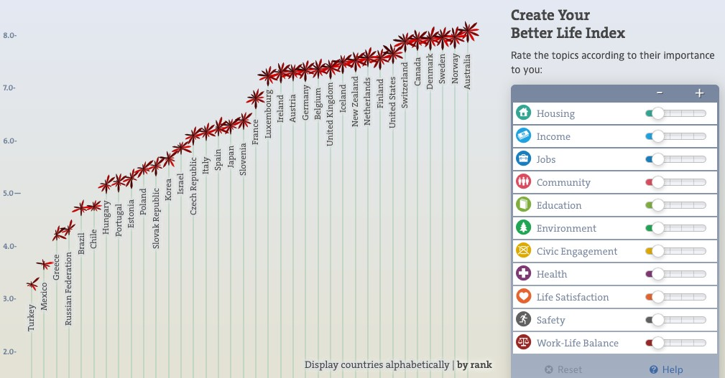

Source: <http://www.oecdbetterlifeindex.org/>

**Figure 2:** OECD Better Life Index – UK Summary

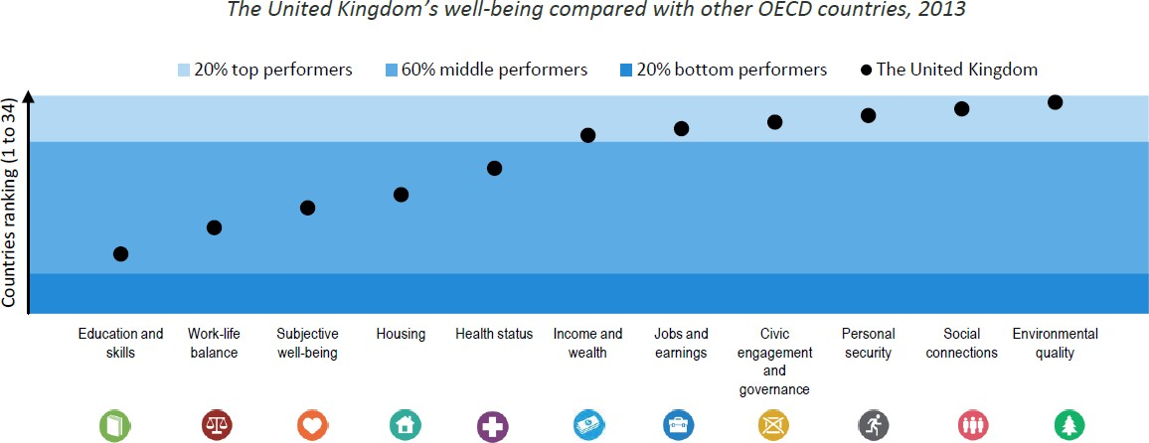

Source: <http://www.oecdbetterlifeindex.org/>

**Figure 3:** Examples of activities which do and do not count as volunteering under the definition given by the International Labour Organisation

|  |  |
| --- | --- |
| **Classed as ‘volunteering’** | **Lies outside the boundary of ‘volunteering’** |
| Working in a soup kitchen cooking meals for the  homeless | Cooking meals for one’s own children |
| Serving on a neighbourhood clean-up committee | Cleaning one’s own house or yard |
| Serving as an usher or otherwise working on  behalf of a religious organisation | Attending a religious service |
| Providing unpaid legal advice at a legal services  agency | Receiving payment for legal advice or assistance |
| Providing marginally paid foster-care services on  a short-term basis | Providing foster-care services on a long-term  basis |
| Sewing a blanket for a sick neighbour | Sewing a blanket for a sick household member |

Source: ILO (2011), Manual on the measurement of volunteer work (adapted).

**Figure 4:** Estimates of the extent of formal volunteering in the UK in 2012

|  |  |  |
| --- | --- | --- |
|  | **Total (at least once per year)** | **Of which frequent (at least once**  **per month)** |
| Hours (billions per  year) | 2.29 | 2.12 |
| Proportion of the  sample | 44% | 29% |

Source: ONS (2013), ‘Household Satellite Accounts: Valuing Voluntary Activity in the UK’. Underlying data from the Community Life Survey.

**Figure 5:** The global volunteer workforce relative to the adult population of the world’s largest countries

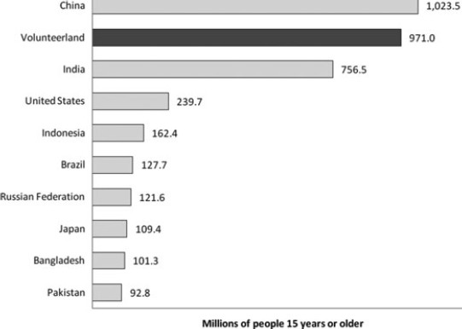

Source: Salamon, Sokolowski and Haddock (2011).

**Figure 6:** Proportion of people in a selection of countries who volunteer at least once per month

|  |  |  |
| --- | --- | --- |
| **Country** | **Rank** | **Proportion of respondents who volunteered in the month prior to**  **interview** |
| Turkmenistan | 1 | 57 |
| Sri Lanka | 2 | 46 |
| United States of  America | 3 | 45 |
| Myanmar | 4 | 43 |
| Philippines | 4 | 43 |
| Canada | 6 | 42 |
| Tajikistan | 7 | 41 |
| New Zealand | 8 | 40 |
| Guatemala | 8 | 40 |
| Uzbekistan | 10 | 38 |
| Ireland | 11= | 37 |
| Netherlands | 11= | 37 |
| State of Libya | 11= | 37 |
| Nigeria | 14 | 36 |
| **United Kingdom** | **26** | **29** |
| Germany | 34 | 27 |
| France | 41 | 25 |
| India | 68 | 18 |
| Spain | 75 | 17 |
| Sweden | 90 | 13 |
| Iraq | 102 | 11 |
| China | 131= | 4 |
| Greece | 131= | 4 |

Source: Charities Aid Foundation World Giving Index (adapted), based on poll carried out by Gallup. The sample includes 135 countries representing 94% of the world’s population.

**Figure 7:** Average number of hours volunteered by age group in 2011

|  |  |
| --- | --- |
| **Age group** | **Average number of hours**  **volunteered per year\*** |
| 16 to 29 | 87 |
| 30 to 49 | 77 |
| 50 to 69 | 109 |
| Older than 70 | 113 |
| UK average | 97 |

Sources: ONS (2013), ‘Household satellite accounts: valuing voluntary activity in the UK’. Underlying data from the Understanding Society survey.

*Conditional on volunteering.

**Figure 8:** Change in volunteering activity over time in the UK

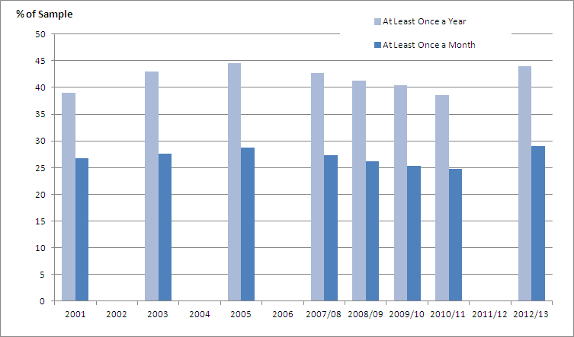

Source: Chart reproduced from ONS, ‘Household satellite accounts: valuing voluntary activity in the UK’. Original data come from Home Office, DCLG and Cabinet Office surveys.

**Figure 9:** The “Volunteering Onion”, a summary of the estimated contribution from volunteering activities in the UK



**Social value**

Social impact multipliers of 2-10?

**Private value**

Probably more than

£40bn per year*

**Economic value**

Around £50bn per year

**Labour input**

15m volunteers 1.25m FTE

Source: Bank and Pro Bono Economics calculations.

Note: The estimate of private value shown is an estimate of the benefits to an individual’s well-being, not including health benefits or improvements to an individual’s skills or employability.

**Figure 10:** Illustrative calculation of the economic contribution to the UK economy beyond formal volunteering (£23.9bn in 2012).

|  |  |
| --- | --- |
| Infrequent volunteering (less than once per month) | Data quality is less good than for frequent  volunteering, but ONS estimate this could add a further £1.7bn |
| Informal volunteering (not through organisations) | The ONS have recently put out an estimate of the total value of informal volunteering in 2012. It is nearly as significant as formal volunteering, and its contribution is estimated at £18.6bn (both  frequent and infrequent). |
| Official estimates only measure the value of labour inputs to volunteering, not the outputs. | You need to make assumptions here about the role of capital, and the level of productivity in volunteer jobs. Based on rough calculations that treat volunteer jobs like labour-intensive service industries, the current method could be understating “output” by perhaps a quarter. But  this is very uncertain. |
| Hard to know whether volunteers perform in the same way as paid workers (whose wages are  used as a proxy for volunteer output) | It could be that volunteers are less productive than experienced workers in some jobs. But they  might be more enthusiastic. |
| *Potential higher estimate (very uncertain)* | *1.25*(18.6 + 1.7 + 23.9) -> gives you around*  *£55bn as a possible alternative estimate.* |

Source: Bank and Pro Bono Economics calculations.

**Figure 11:** Survey responses for volunteering regularly

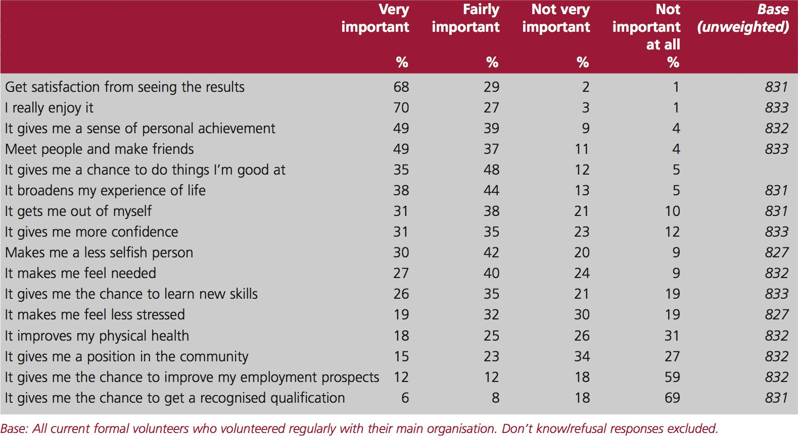

Source: 2006/07 Helping Out survey.

**Figure 12:** The average lifetime cost of risk factors associated with sexual exploitation

|  |  |  |  |  |  |
| --- | --- | --- | --- | --- | --- |
|  | Average cost per individual | | | |  |
|  | Going missing | Substance abuse | Dis- engagement from  education | Accommodation needs | Total |
| Pre-  intervention | £19,664 | £4,278 | £10,504 | £11,338 | £45,784 |
| Post-  intervention | £7,551 | £3,047 | £8,327 | £9,223 | £28,148 |
| Control group | £24,235 | £5,057 | £17,312 | £16,904 | £63,508 |

Source: PBE (2011).

**Figure 13:** Benefit of Centrepoint intervention to the public purse, average per Centrepoint client

|  |  |
| --- | --- |
|  | Central scenario  (£, 2010/11 prices) |
| Avoided welfare benefits | 6,989 |
| Tax raised | 12,332 |
| Crime (avoided costs) | 2,639 |
| Mental health issues (treatment costs avoided) | 46 |
| Class A drugs (treatment costs avoided) | 188 |
| Cannabis (treatment costs avoided) | 117 |
| Alcohol (treatment costs avoided) | –136 |
| **Benefit of Centrepoint intervention to the public purse** | **22,174** |

Source: PBE (2013).

Note: row totals do not add to the total benefit due to rounding.

**Figure 14:** Reasons for not participating in volunteering-related activities, 2010/2011 (% of respondents)

|  |  |
| --- | --- |
| Work commitments | 60% |
| Doing other things with spare time | 34% |
| Looking after children/the home | 31% |
| Studying commitments | 14% |
| Not knowing any opportunities to help | 14% |
| Not knowing of any groups needing help | 14% |
| Looking after someone elderly or ill | 8% |
| Feeling too old | 3% |
| Feeling too young | 1% |

Source: UK Civil Society Almanac (2014), Citizenship Survey (2010/11).

**References**

**Booth, C, Cameron, D, Cumming, L, Gilby, N, Hale, C, Hoolahan (2014)** ‘National Citizen Service 2013 Evaluation Report’, *Ipsos Mori: Social Research Institute*: <http://www.ncsyes.co.uk/sites/all/themes/ncs/pdf/ncs_2013_evaluation_report_final.pdf>

**Campbell, R and Fujiwara, D,** ‘Valuation Techniques for Social Cost-Benefit Analysis’, *Department for Work and Pensions and HM Treasury*: [https://www.gov.uk/government/uploads/system/uploads/attachment_data/file/209107/greenbook_valuationt](https://www.gov.uk/government/uploads/system/uploads/attachment_data/file/209107/greenbook_valuationtechniques.pdf) [echniques.pdf](https://www.gov.uk/government/uploads/system/uploads/attachment_data/file/209107/greenbook_valuationtechniques.pdf)

**Casiday, R, Kinsman, E, Fisher, C, and Bambra, C (2008),** ‘Volunteering and Health: What Impact Does It Really Have?’. *Report commissioned by Volunteering England and carried out by the University of Wales Lampeter.* <http://www.ivr.org.uk/ivr-news/133-volunteering-health-what-impact-does-it-really-have>

**Centre for Mental Health, (2010),** ‘The economic and social costs of mental health problems in 2009/10’: <http://www.centreformentalhealth.org.uk/pdfs/Economic_and_social_costs_2010.pdf>

**Charities Aid Foundation, (2013**), ‘World Giving Index 2013’: <https://www.cafonline.org/PDF/WorldGivingIndex2013_1374AWEB.pdf>

**Coyle, D., (2014),** ‘Measuring economic progress’, *VoxEU*: [http://www.voxeu.org/article/measuring-](http://www.voxeu.org/article/measuring-economic-progress) [economic-progress](http://www.voxeu.org/article/measuring-economic-progress)

**Deaton, A, Durand, M, Halpern, D, and Layard, L, O’Donnell, G (2014),** ‘Wellbeing and Policy’, Report of the Commission on Wellbeing and Policy (commissioned by The Legatum Institute): [http://li.com/docs/default-source/commission-on-wellbeing-and-policy/commission-on-wellbeing-and-policy-](http://li.com/docs/default-source/commission-on-wellbeing-and-policy/commission-on-wellbeing-and-policy-report---march-2014-pdf-.pdf?sfvrsn=5) [report---march-2014-pdf-.pdf?sfvrsn=5](http://li.com/docs/default-source/commission-on-wellbeing-and-policy/commission-on-wellbeing-and-policy-report---march-2014-pdf-.pdf?sfvrsn=5)

**Diener, E, Lyubomirsky, S, and King, L (2005),** ‘The Benefits of Frequent Positive Affect: Does Happiness Lead to Success?’, *Psychological Bulletin, Vol. 131 No. 6.* [http://sonjalyubomirsky.com/wp-](http://sonjalyubomirsky.com/wp-content/themes/sonjalyubomirsky/papers/LKD2005.pdf) [content/themes/sonjalyubomirsky/papers/LKD2005.pdf](http://sonjalyubomirsky.com/wp-content/themes/sonjalyubomirsky/papers/LKD2005.pdf)

**Dunn, E, Aknin, L, and Norton, M, (2014)** ‘Prosocial Spending and Happiness: Using Money to Benefit Others Pays Off’, *Current Directions in Psychological Science 2014* [http://www.hbs.edu/faculty/Publication%20Files/Dunn%20Aknin%20%20Norton%20-2014%20CD_bfccfc43-](http://www.hbs.edu/faculty/Publication%20Files/Dunn%20Aknin%20%20Norton%20-2014%20CD_bfccfc43-4139-476a-904b-ebcf855ab7c3.pdf) [4139-476a-904b-ebcf855ab7c3.pdf](http://www.hbs.edu/faculty/Publication%20Files/Dunn%20Aknin%20%20Norton%20-2014%20CD_bfccfc43-4139-476a-904b-ebcf855ab7c3.pdf)

**Ellis Paine, A., McKay, S., and D. Moro, (2013),** ‘Does volunteering improve employability? Evidence from the British Household Panel Survey’, *Third Sector Research Centre Briefing Paper 100 and Working Paper 100.*

**Estrada, C.A., Isen, A.M., and M.J. Young, (1997),** ‘Positive Affect Facilitates Integration of Information and Decreases Anchoring in Reasoning among Physicians’, Organizational Behavior and Human Decision Processes Vol.72, No.1, October, pp.117-135.

**Frey, B, Benesch, C, and Stutzer, A, (2007)** ‘Does watching TV make us happy?’, *Journal of Economic Psychology*, 28, pp.283-313.

**Fujiwara, D, Leach, M, Trotter, L, Vine, J (2014)** ‘Measuring the Social Impact of Community Investment: A Guide to using the Wellbeing Valuation Approach’, *HACT: ideas and innovation in housing.*

**Gaskin, K, (2011)** ‘VIVA – The volunteer investment and value audit. A self-help guide’, *Institute for Volunteering Research:* [http://www.ivr.org.uk/component/ivr/viva--the-volunteer-investment-and-value-audit-](http://www.ivr.org.uk/component/ivr/viva--the-volunteer-investment-and-value-audit-a-self-help-guide%26qh%3DYToxOntpOjA7czo0OiJ2aXZhIjt9) [a-self-help-guide&qh=YToxOntpOjA7czo0OiJ2aXZhIjt9](http://www.ivr.org.uk/component/ivr/viva--the-volunteer-investment-and-value-audit-a-self-help-guide%26qh%3DYToxOntpOjA7czo0OiJ2aXZhIjt9)

**Guild, M, Harrison, T, Saxton, J, (2014)** ‘The New Alchemy: How volunteering turns donations of time and talent into human gold time’, *nfpSynergy:* [http://nfpsynergy.net/free-report/new-alchemy-how-volunteering-](http://nfpsynergy.net/free-report/new-alchemy-how-volunteering-turns-donations-time-and-talent-human-gold-part-1) [turns-donations-time-and-talent-human-gold-part-1](http://nfpsynergy.net/free-report/new-alchemy-how-volunteering-turns-donations-time-and-talent-human-gold-part-1)

**Helliwell, J.F., Layard, R., and J.D. Sachs (eds.), (2013),** ‘World Happiness Report 2013’, UN Sustainable Development Solutions Network: <http://unsdsn.org/resources/publications/world-happiness-report-2013/>

**International Labour Organisation, (2011),** ‘Manual on the measurement of volunteer work*’*: <http://www.ilo.org/wcmsp5/groups/public/---dgreports/---stat/documents/publication/wcms_162119.pdf>

**Low, N., Butt, S., Ellis Paine, A. and J. Davis Smith, (2007),** ‘Helping Out: A national survey of volunteering and charitable giving’. Cabinet Office: London. [http://www.ivr.org.uk/component/ivr/helping-out-](http://www.ivr.org.uk/component/ivr/helping-out-a-national-survey-of-volunteering-and-charitable-giving) [a-national-survey-of-volunteering-and-charitable-giving](http://www.ivr.org.uk/component/ivr/helping-out-a-national-survey-of-volunteering-and-charitable-giving)

**MacKerrona, G, Muratoc,S (2013)** ‘Happiness is greater in natural environments’, *Global Environmental Change Vol 23 Issue 5.*

**Meier, S and Stuzer, A (2004)** “Is volunteering rewarding in itself?” *Forschungsinstitut zur Zukunft der Arbeit*: <http://ftp.iza.org/dp1045.pdf>

**National Council for Voluntary Organisations (NCVO), (2014),** ‘UK Civil Society Almanac 2014’: <http://data.ncvo.org.uk/category/almanac/>

**OECD, (2013), ‘How’s Life? 2013**: Measuring Well-being’, OECD Publishing. <http://www.oecd.org/statistics/howslife.htm>

**OECD Better Life Index**: <http://www.oecdbetterlifeindex.org/>

**ONS, (2013),** ‘Household Satellite Accounts: Valuing Voluntary Activity in the UK’: [http://www.ons.gov.uk/ons/rel/wellbeing/household-satellite-accounts/valuing-voluntary-activity-in-the-uk/art--](http://www.ons.gov.uk/ons/rel/wellbeing/household-satellite-accounts/valuing-voluntary-activity-in-the-uk/art--valuing-voluntary-activity-in-the-uk.html) [valuing-voluntary-activity-in-the-uk.html](http://www.ons.gov.uk/ons/rel/wellbeing/household-satellite-accounts/valuing-voluntary-activity-in-the-uk/art--valuing-voluntary-activity-in-the-uk.html)

**ONS, (2014),** ‘Measuring National Well-being: Life in the UK’: [http://www.ons.gov.uk/ons/rel/wellbeing/measuring-national-well-being/life-in-the-uk--2014/art-mnwb--life-in-](http://www.ons.gov.uk/ons/rel/wellbeing/measuring-national-well-being/life-in-the-uk--2014/art-mnwb--life-in-the-uk--2014.html#tab-Overview) [the-uk--2014.html#tab-Overview](http://www.ons.gov.uk/ons/rel/wellbeing/measuring-national-well-being/life-in-the-uk--2014/art-mnwb--life-in-the-uk--2014.html#tab-Overview)

**Oswald, A.J., Proto, E. and D. Sgroi, (2014),** ‘Happiness and Productivity’, *Working Paper*: <http://www2.warwick.ac.uk/fac/soc/economics/staff/eproto/workingpapers/happinessproductivity.pdf>

**PBE (2011) ‘**An assessment of the potential savings from Barnardo’s interventions for young people who have been sexually exploited’, *Pro Bono Economics*: [http://www.probonoeconomics.com/news/publications/pbe-report-assesses-effectiveness-and-value-](http://www.probonoeconomics.com/news/publications/pbe-report-assesses-effectiveness-and-value-barnardo%E2%80%99s-services-sexually-exploited) [barnardo%E2%80%99s-services-sexually-exploited](http://www.probonoeconomics.com/news/publications/pbe-report-assesses-effectiveness-and-value-barnardo%E2%80%99s-services-sexually-exploited)

**PBE (2013)** ‘Impact of Centrepoint’s intervention for homeless young people’, *Pro Bono Economics*: [http://www.probonoeconomics.com/news/publications/understanding-value-centrepoint%E2%80%99s-](http://www.probonoeconomics.com/news/publications/understanding-value-centrepoint%E2%80%99s-services) [services](http://www.probonoeconomics.com/news/publications/understanding-value-centrepoint%E2%80%99s-services)

**Salamon L., Sokolowski S. and M. Haddock, (2011),** ‘Measuring the economic value of volunteer work globally – concepts, estimates and a roadmap to the future*’*, *Annals of Public and Cooperative Economics Vol. 82, No. 3.*

**Stiglitz, J.E., Sen, A., and J.P. Fitoussi, (2009),** ‘Report by the Commission on the Measurement of Economic Performance and Social Progress’: [http://www.stiglitz-sen-](http://www.stiglitz-sen-fitoussi.fr/documents/rapport_anglais.pdf) [fitoussi.fr/documents/rapport_anglais.pdf](http://www.stiglitz-sen-fitoussi.fr/documents/rapport_anglais.pdf)

**Volunteering England, (2009),** ‘Volunteering England Information Sheet’: [http://www.volunteering.org.uk/images/stories/Volunteering-England/Documents/Free-Information-Sheets/IS-](http://www.volunteering.org.uk/images/stories/Volunteering-England/Documents/Free-Information-Sheets/IS---National-Statistics--(VE09).pdf?phpMyAdmin=ea19469af65d57852a6dcf96ae252f42&phpMyAdmin=af59e0793933f8849c29e6a3a0aa550d&phpMyAdmin=aOV51K4pN6n2U-SVePLZzBRWAjd)

[--National-Statistics--](http://www.volunteering.org.uk/images/stories/Volunteering-England/Documents/Free-Information-Sheets/IS---National-Statistics--(VE09).pdf?phpMyAdmin=ea19469af65d57852a6dcf96ae252f42&phpMyAdmin=af59e0793933f8849c29e6a3a0aa550d&phpMyAdmin=aOV51K4pN6n2U-SVePLZzBRWAjd) [(VE09).pdf?phpMyAdmin=ea19469af65d57852a6dcf96ae252f42&phpMyAdmin=af59e0793933f8849c29e6a](http://www.volunteering.org.uk/images/stories/Volunteering-England/Documents/Free-Information-Sheets/IS---National-Statistics--(VE09).pdf?phpMyAdmin=ea19469af65d57852a6dcf96ae252f42&phpMyAdmin=af59e0793933f8849c29e6a3a0aa550d&phpMyAdmin=aOV51K4pN6n2U-SVePLZzBRWAjd) [3a0aa550d&phpMyAdmin=aOV51K4pN6n2U-SVePLZzBRWAjd](http://www.volunteering.org.uk/images/stories/Volunteering-England/Documents/Free-Information-Sheets/IS---National-Statistics--(VE09).pdf?phpMyAdmin=ea19469af65d57852a6dcf96ae252f42&phpMyAdmin=af59e0793933f8849c29e6a3a0aa550d&phpMyAdmin=aOV51K4pN6n2U-SVePLZzBRWAjd)

**Wright, T.A., and B.M. Staw, (1999),** ‘Affect and favorable work outcomes: two longitudinal tests of the happy-productive worker thesis’. Journal of Organizational Behavior 20, 1-23.